**WITH NOISE AND WITH FILTER FUZZY**

**Image set:**

|  |
| --- |
| **Image 1:-0.1 % Noise** |

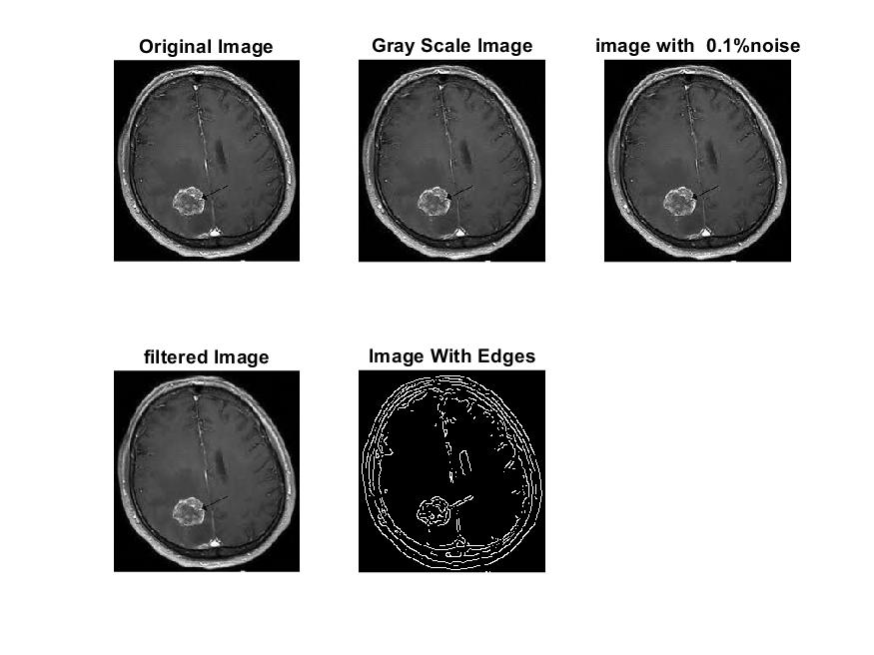

**Image 2:-10 % Noise**

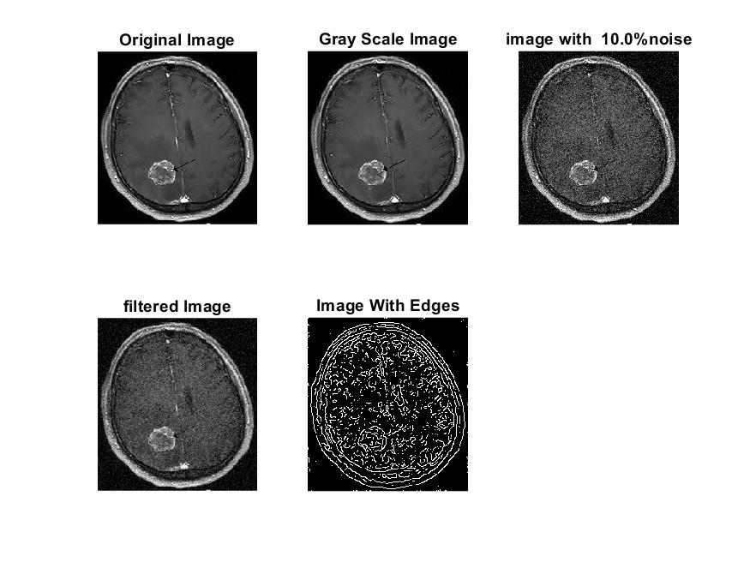

**Image 3:-20 % Noise**

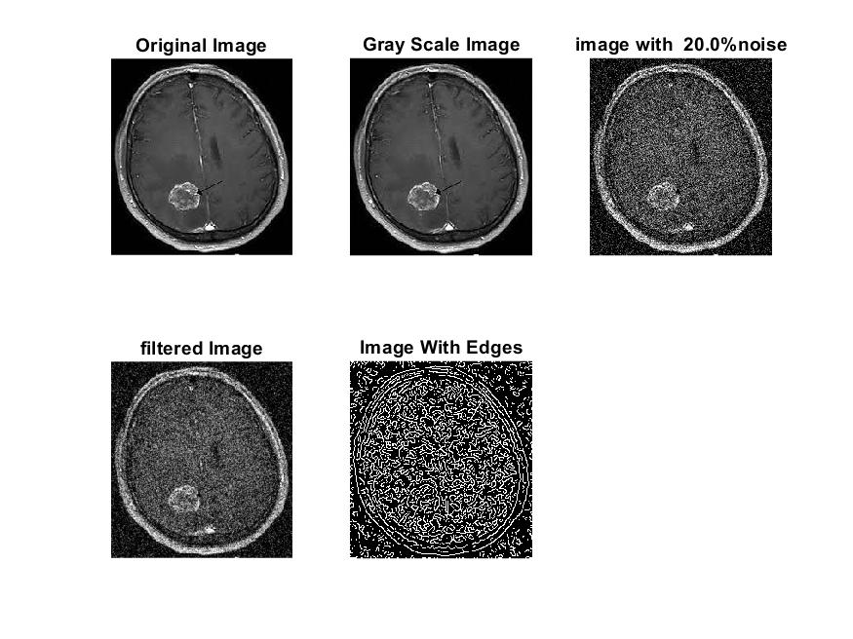

**Image 4:-30 % Noise**

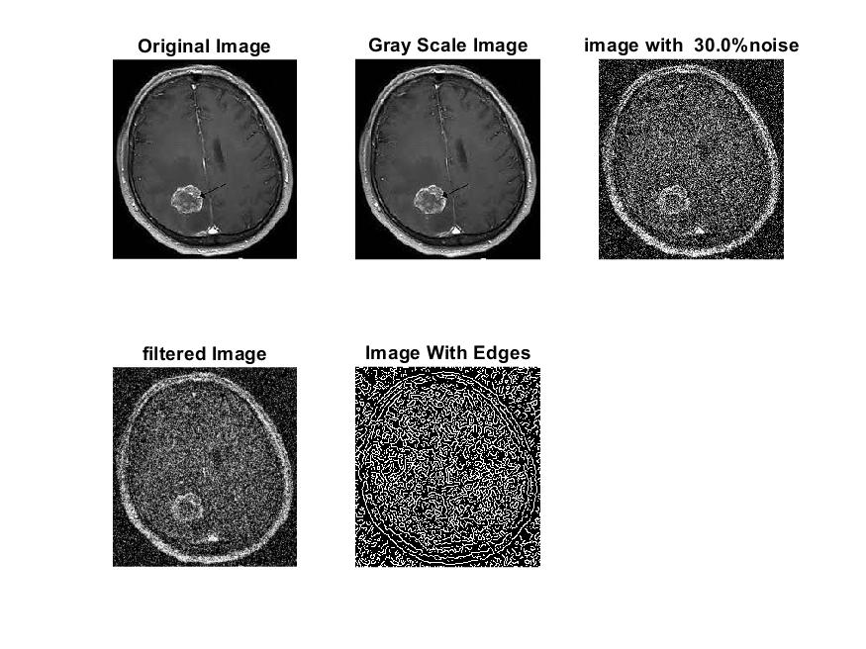

|  |
| --- |
| **Image 5:-40 % Noise** |

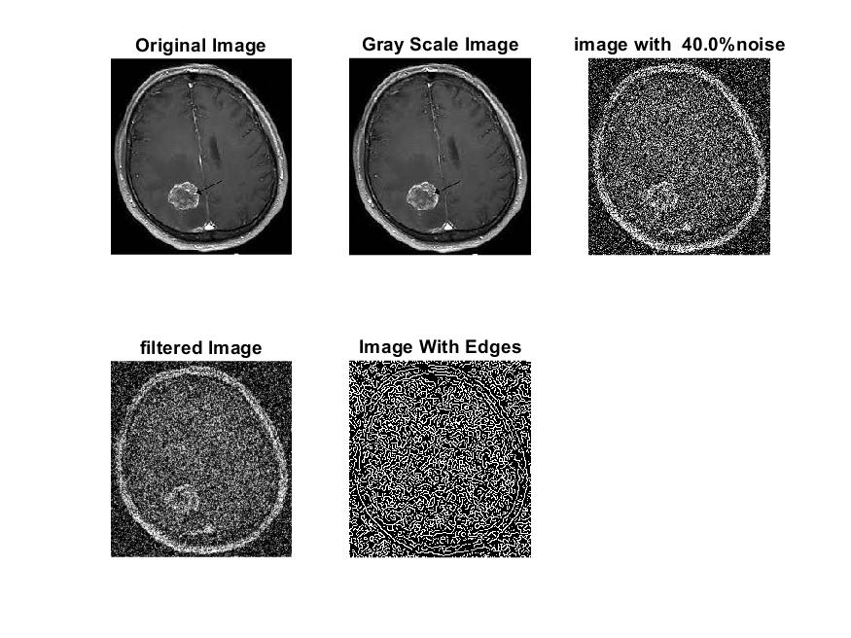

**Image 6:-50 % Noise**

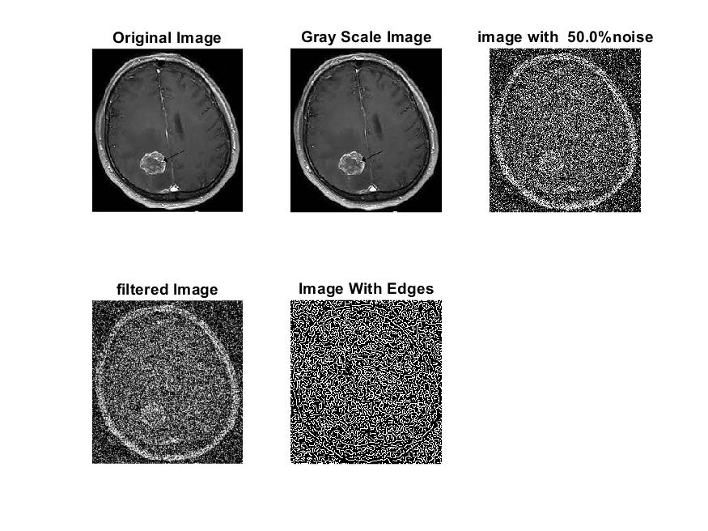

**Image 7:-60 % Noise**

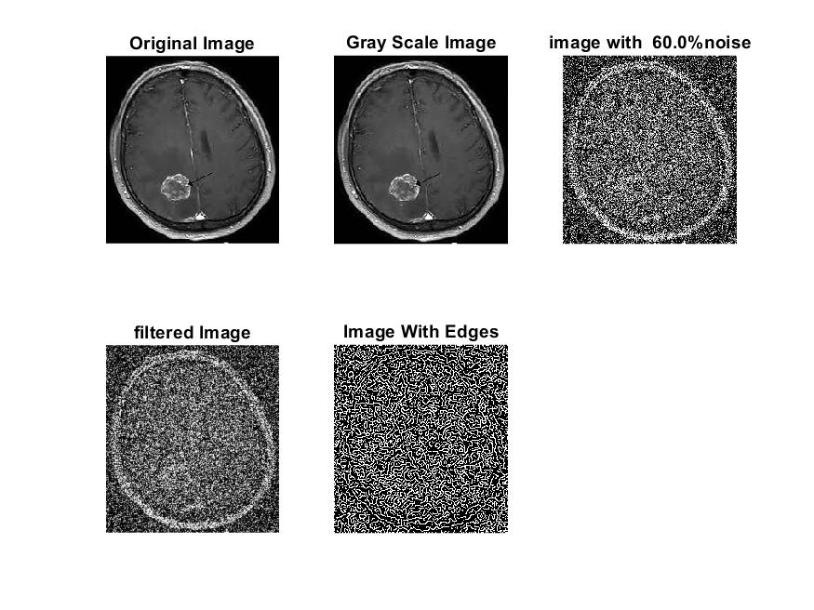

**Image 8:-70 % Noise**

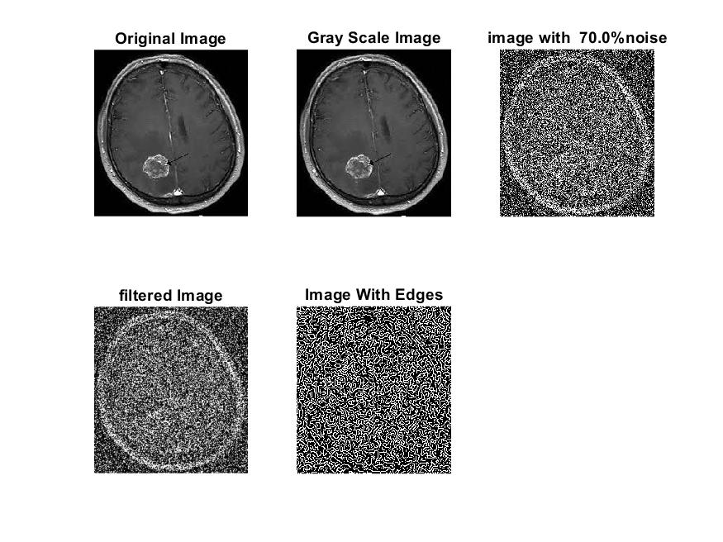

**Image 9:-80 % Noise**

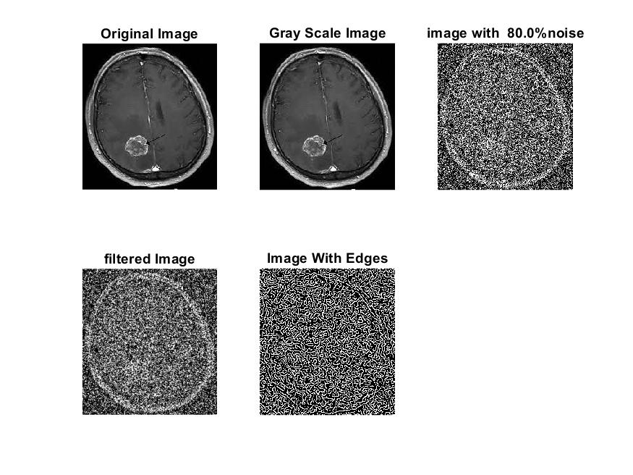

**DATA FILES**

**Image 1:-Noise0.1**

Original image ideal values:

IM1 image entropy:4.125151e-01

IM1 image mean:0.082957

Ground truth image entropy:0.746959

Ground truth image mean:0.212884

entropy between imt and im1 :0.679431

MSE between imt and im1 :0.229483

Average Difference between imt and im1 :0.129926

Maximum Difference between imt and im1 :1.000000

True Positive values:1677.000000

False Positive values: 2516.000000

True Negative values:37268.000000

False Negative values:9083.000000

Accuracy value: 0.770517

F Measure values:0.224303

Peak Signal-to Noise Ration value: 6.392491

Signal-to Noise Ration value: -4.092874

percentage of pixels that were correctly detected (Pco): 0.155855

The percentage of pixels that were not detected (Pnd):0.844145

the percentage of false alarm: (Pfa):0.233829

Euclidean Distance Value :14.637713

**Image 2:-Noise10**

Original image ideal values:

IM1 image entropy:5.699614e-01

IM1 image mean:0.134615

Ground truth image entropy:0.746959

Ground truth image mean:0.212884

entropy between imt and im1 :0.662862

MSE between imt and im1 :0.266263

Average Difference between imt and im1 :0.078268

Maximum Difference between imt and im1 :1.000000

True Positive values:2053.000000

False Positive values: 4751.000000

True Negative values:35033.000000

False Negative values:8707.000000

Accuracy value: 0.733737

F Measure values:0.233774

Peak Signal-to Noise Ration value: 5.746891

Signal-to Noise Ration value: -1.990480

percentage of pixels that were correctly detected (Pco): 0.190799

The percentage of pixels that were not detected (Pnd):0.809201

the percentage of false alarm: (Pfa):0.441543

Euclidean Distance Value :18.122740

**Image 3:-Noise20**

Original image ideal values:

IM1 image entropy:8.008621e-01

IM1 image mean:0.243530

Ground truth image entropy:0.746959

Ground truth image mean:0.212884

entropy between imt and im1 :0.638973

MSE between imt and im1 :0.354562

Average Difference between imt and im1 :-0.030647

Maximum Difference between imt and im1 :1.000000

True Positive values:2574.000000

False Positive values: 9735.000000

True Negative values:30049.000000

False Negative values:8186.000000

Accuracy value: 0.645438

F Measure values:0.223157

Peak Signal-to Noise Ration value: 4.503074

Signal-to Noise Ration value: 0.584105

percentage of pixels that were correctly detected (Pco): 0.209115

The percentage of pixels that were not detected (Pnd):0.665042

the percentage of false alarm: (Pfa):0.790885

Euclidean Distance Value :19.961373

**Image 4:-Noise30**

Original image ideal values:

IM1 image entropy:8.747573e-01

IM1 image mean:0.294733

Ground truth image entropy:0.746959

Ground truth image mean:0.212884

entropy between imt and im1 :0.619188

MSE between imt and im1 :0.389384

Average Difference between imt and im1 :-0.081849

Maximum Difference between imt and im1 :1.000000

True Positive values:2988.000000

False Positive values: 11909.000000

True Negative values:27875.000000

False Negative values:7772.000000

Accuracy value: 0.610616

F Measure values:0.232919

Peak Signal-to Noise Ration value: 4.096224

Signal-to Noise Ration value: 1.412865

percentage of pixels that were correctly detected (Pco): 0.200577

The percentage of pixels that were not detected (Pnd):0.521716

the percentage of false alarm: (Pfa):0.799423

Euclidean Distance Value :19.104451

**Image 5:-Noise40**

Original image ideal values:

IM1 image entropy:9.018665e-01

IM1 image mean:0.317703

Ground truth image entropy:0.746959

Ground truth image mean:0.212884

entropy between imt and im1 :0.614003

MSE between imt and im1 :0.408159

Average Difference between imt and im1 :-0.104820

Maximum Difference between imt and im1 :1.000000

True Positive values:3094.000000

False Positive values: 12964.000000

True Negative values:26820.000000

False Negative values:7666.000000

Accuracy value: 0.591841

F Measure values:0.230741

Peak Signal-to Noise Ration value: 3.891704

Signal-to Noise Ration value: 1.738792

percentage of pixels that were correctly detected (Pco): 0.192677

The percentage of pixels that were not detected (Pnd):0.477394

the percentage of false alarm: (Pfa):0.807323

Euclidean Distance Value :18.315172

**Image 6:-Noise50**

Original image ideal values:

IM1 image entropy:9.140442e-01

IM1 image mean:0.329139

Ground truth image entropy:0.746959

Ground truth image mean:0.212884

entropy between imt and im1 :0.604137

MSE between imt and im1 :0.411720

Average Difference between imt and im1 :-0.116255

Maximum Difference between imt and im1 :1.000000

True Positive values:3293.000000

False Positive values: 13343.000000

True Negative values:26441.000000

False Negative values:7467.000000

Accuracy value: 0.588280

F Measure values:0.240400

Peak Signal-to Noise Ration value: 3.853975

Signal-to Noise Ration value: 1.892366

percentage of pixels that were correctly detected (Pco): 0.197944

The percentage of pixels that were not detected (Pnd):0.448846

the percentage of false alarm: (Pfa):0.802056

Euclidean Distance Value :18.839421

**Image 7:-Noise60**

Original image ideal values:

IM1 image entropy:9.178004e-01

IM1 image mean:0.332839

Ground truth image entropy:0.746959

Ground truth image mean:0.212884

entropy between imt and im1 :0.597849

MSE between imt and im1 :0.410474

Average Difference between imt and im1 :-0.119955

Maximum Difference between imt and im1 :1.000000

True Positive values:3418.000000

False Positive values: 13405.000000

True Negative values:26379.000000

False Negative values:7342.000000

Accuracy value: 0.589526

F Measure values:0.247834

Peak Signal-to Noise Ration value: 3.867143

Signal-to Noise Ration value: 1.940912

percentage of pixels that were correctly detected (Pco): 0.203174

The percentage of pixels that were not detected (Pnd):0.436426

the percentage of false alarm: (Pfa):0.796826

Euclidean Distance Value :19.360577

**Image 8:-Noise70**

Original image ideal values:

IM1 image entropy:9.282236e-01

IM1 image mean:0.343602

Ground truth image entropy:0.746959

Ground truth image mean:0.212884

entropy between imt and im1 :0.586557

MSE between imt and im1 :0.412492

Average Difference between imt and im1 :-0.130718

Maximum Difference between imt and im1 :1.000000

True Positive values:3639.000000

False Positive values: 13728.000000

True Negative values:26056.000000

False Negative values:7121.000000

Accuracy value: 0.587508

F Measure values:0.258755

Peak Signal-to Noise Ration value: 3.845844

Signal-to Noise Ration value: 2.079125

percentage of pixels that were correctly detected (Pco): 0.209535

The percentage of pixels that were not detected (Pnd):0.410031

the percentage of false alarm: (Pfa):0.790465

Euclidean Distance Value :19.994254

**Image 9:-Noise80**

Original image ideal values:

IM1 image entropy:9.253863e-01

IM1 image mean:0.340594

Ground truth image entropy:0.746959

Ground truth image mean:0.212884

entropy between imt and im1 :0.590978

MSE between imt and im1 :0.412888

Average Difference between imt and im1 :-0.127711

Maximum Difference between imt and im1 :1.000000

True Positive values:3553.000000

False Positive values: 13662.000000

True Negative values:26122.000000

False Negative values:7207.000000

Accuracy value: 0.587112

F Measure values:0.254013

Peak Signal-to Noise Ration value: 3.841680

Signal-to Noise Ration value: 2.040948

percentage of pixels that were correctly detected (Pco): 0.206390

The percentage of pixels that were not detected (Pnd):0.418647

the percentage of false alarm: (Pfa):0.793610

Euclidean Distance Value :19.680747